Data Visualization for Digital Health

**Topic**: Data Analysis Report on Medical Condition relationship with Age

**1.0 Introduction**

This report analyzes the relationship between various medical conditions and patient age demographics using a simulated dataset. Understanding how different ages are affected by specific health issues can aid healthcare providers in tailoring treatments and preventive measures effectively. For this analysis, we will focus on medical conditions like diabetes, hypertension, asthma, cancer, arthritis and obesity.

**1.1 Dataset Description**

There was a data collection on variables like name, gender, age, medical condition, blood group, and Medication, through which I made an analysis on to know how age is correlated to some medical conditions. Find below is a sample of the collected data.

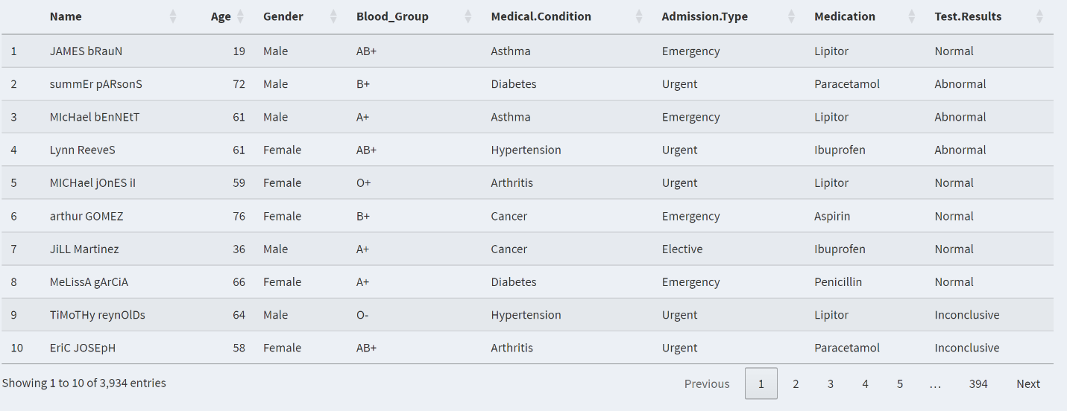

**2.0 Data Analysis and Findings**

Following a data visualization report and a critical analyzing, I observed that most of the medical conditions increases in the number of patients as the value of their Age increases. These medical conditions include hypertension, diabetes and cancer. Figure 2.1 show a data visualization for hypertension medical condition.

Furthermore, medical condition like arthritis and asthma have a higher count in patients at a lower age. This significantly show that these type of medical conditions have the tendency of affecting children as well as adults. Figure 2.2 show a data visualization for asthma medical condition.

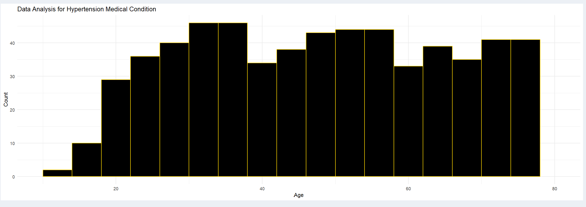

Figure 2.1

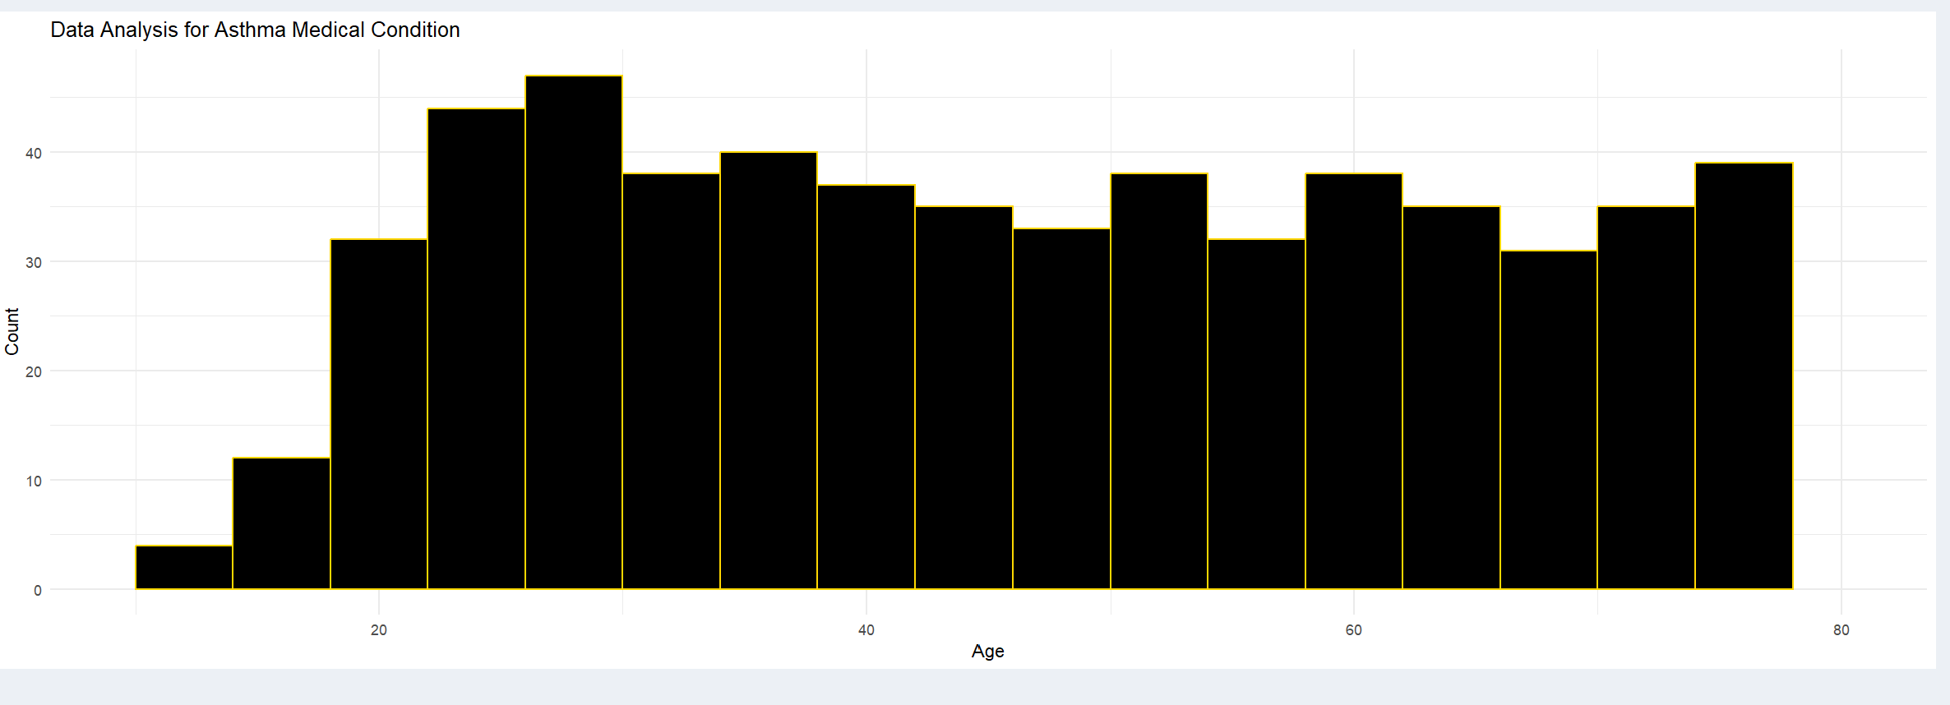

Figure 2.2

**3.0 Conclusion**

Through this analysis and visualization efforts:

* We found certain trends indicating that older adults tend to have higher incidences of chronic diseases such as diabetes and hypertension.
* We also find that, when you compare figure 2.1 and figure 2.2, asthma has an increased number in children or lower age as compared to hypertension.